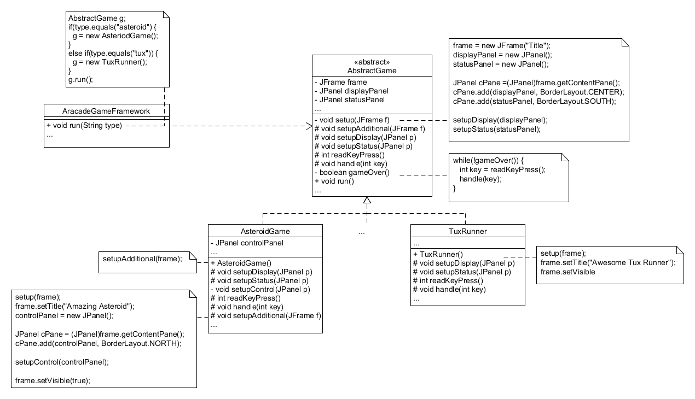

The ArcadeGameFramework has an AbstractGame object and instantiates it at runtime to run the specified game. All of the duplicate setup code has been implemented in the AbstractGame class. If additional JPanels need to be setup, then each class can implement the setupAdditional method. For instance, the AsteroidGame had a control panel that needs to be setup so it implements setupAdditional to do this. Any methods that could have custom implementations such as setupDisplay, setupStatus, readKeyPress, and handle are all implemented in the subclasses. The AbstractGame delegates the logic for these methods to its subclasses. The framework does need to be modified though if additional games are added…